SHOW CREATE TABLE and DATABASE

🎯 Purpose
# Source: AI Source: Provided by: [Data Path: Persons Table -> ID Column: 1, Name_En Column: Motasem Essam] -> From: [ChatGPT] on [6/11/2026]
These commands show the exact SQL statements used to create a table or database — including constraints, character sets, and more. This is useful for backups, migrations, or understanding structure.

✅ Lesson Content

🔹 1. SHOW CREATE DATABASE
# Source: AI Source: Provided by: [Data Path: Persons Table -> ID Column: 1, Name_En Column: Motasem Essam] -> From: [ChatGPT] on [6/11/2026]
Syntax:
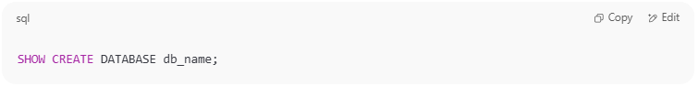
SHOW CREATE DATABASE db_name;

Example:
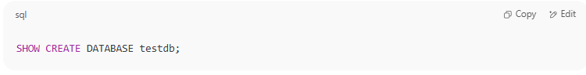
SHOW CREATE DATABASE testdb;

Output:
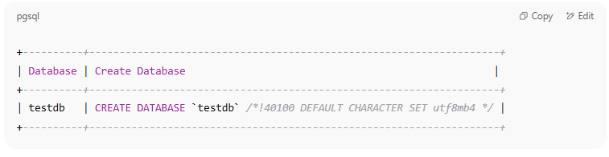
+----------+--------------------------------------------------------------------+
| Database | Create Database |
+----------+--------------------------------------------------------------------+
| testdb | CREATE DATABASE `testdb` /*!40100 DEFAULT CHARACTER SET utf8mb4 */ |
+----------+--------------------------------------------------------------------+

📝 This shows how the database was originally created, including collation and charset.

🔹 2. SHOW CREATE TABLE
# Source: AI Source: Provided by: [Data Path: Persons Table -> ID Column: 1, Name_En Column: Motasem Essam] -> From: [ChatGPT] on [6/11/2026]
Syntax:
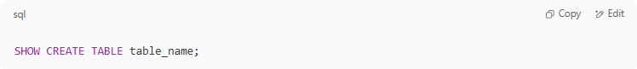
SHOW CREATE TABLE table_name;

Example:
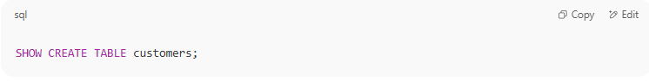
SHOW CREATE TABLE customers;

Output:
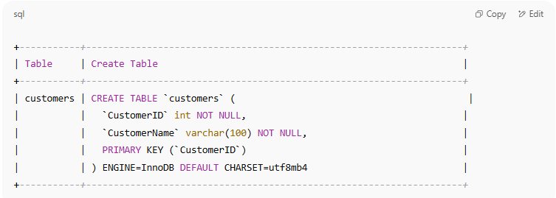
+-----------+--------------------------------------------------------------------+
| Table | Create Table |
+-----------+--------------------------------------------------------------------+
| customers | CREATE TABLE `customers` ( |
| | `CustomerID` int NOT NULL, |
| | `CustomerName` varchar(100) NOT NULL, |
| | PRIMARY KEY (`CustomerID`) |
| | ) ENGINE=InnoDB DEFAULT CHARSET=utf8mb4 |
+-----------+--------------------------------------------------------------------+

📝 This is the full table definition, including primary keys, types, and table engine.

🧪 Practice
# Source: AI Source: Provided by: [Data Path: Persons Table -> ID Column: 1, Name_En Column: Motasem Essam] -> From: [ChatGPT] on [6/11/2026]
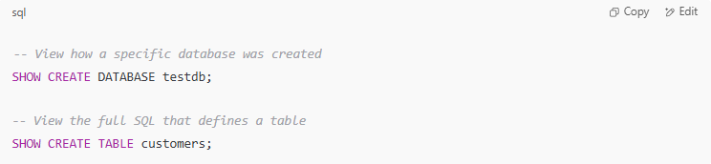
-- View how a specific database was created
SHOW CREATE DATABASE testdb;

-- View the full SQL that defines a table
SHOW CREATE TABLE customers;

🧠 Notes
# Source: AI Source: Provided by: [Data Path: Persons Table -> ID Column: 1, Name_En Column: Motasem Essam] -> From: [ChatGPT] on [6/11/2026]
- You need access privileges to the database or table to use these commands.
- Great for duplicating structures or understanding the schema.

Example

prepared commands
# Source: ScreenShot Source: Provided by: [Persons Table -> ID Column: 1, Name_En Column: Motasem Essam] -> Tool: [Automation Table -> ID Column: 16, Name_En Column: Screen Capture] -> From [Operating System: Wampserver64 -> phpmyadmin] on [6/11/2026]
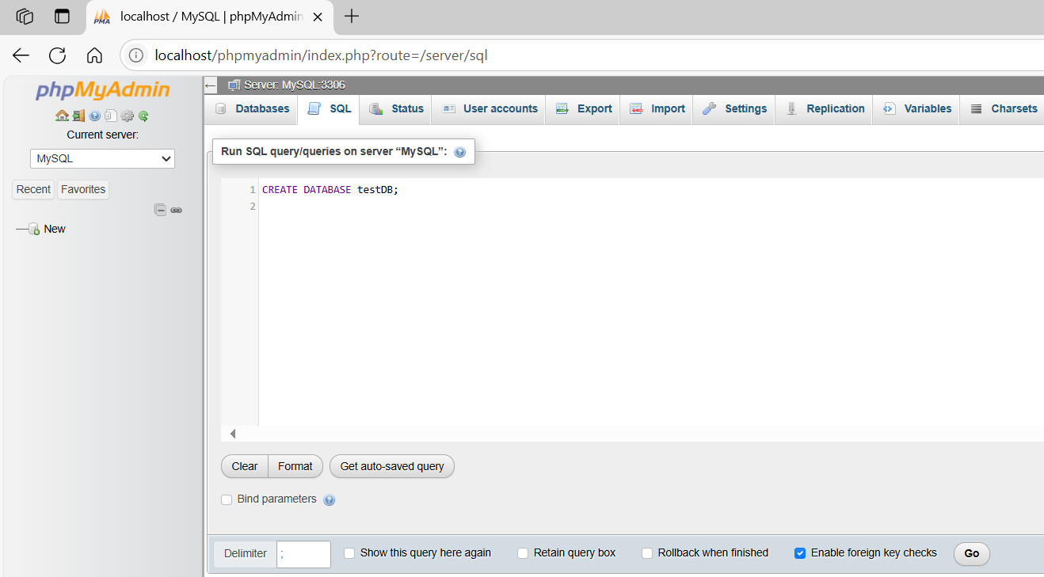
CREATE DATABASE testDB;
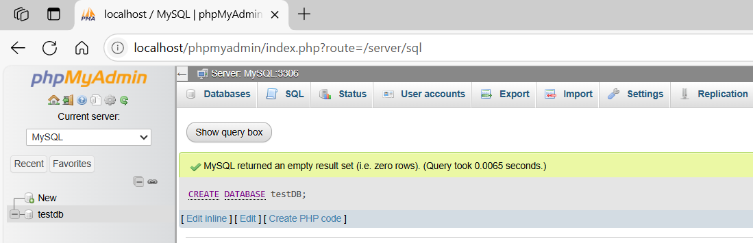
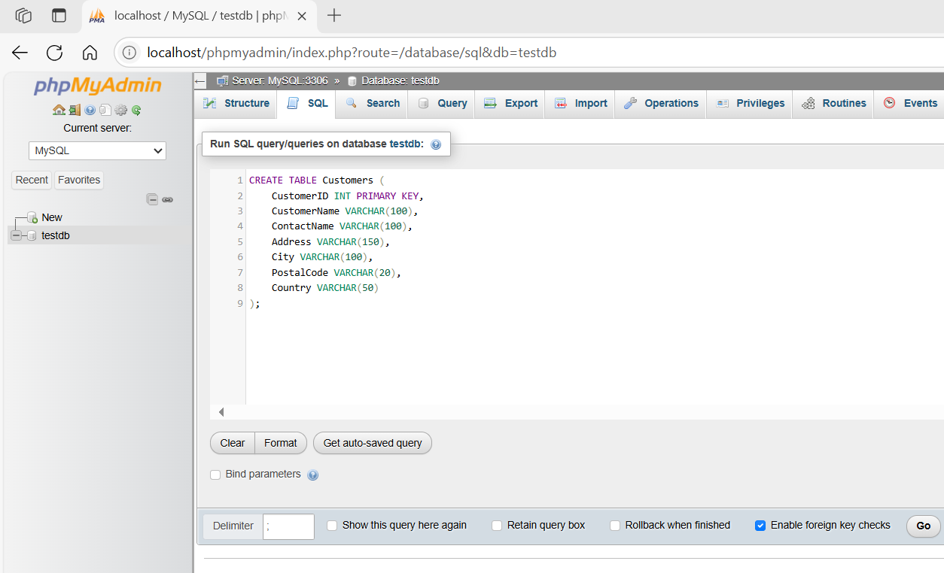
CREATE TABLE Customers (
CustomerID INT PRIMARY KEY,
CustomerName VARCHAR(100),
ContactName VARCHAR(100),
Address VARCHAR(150),
City VARCHAR(100),
PostalCode VARCHAR(20),
Country VARCHAR(50)
);
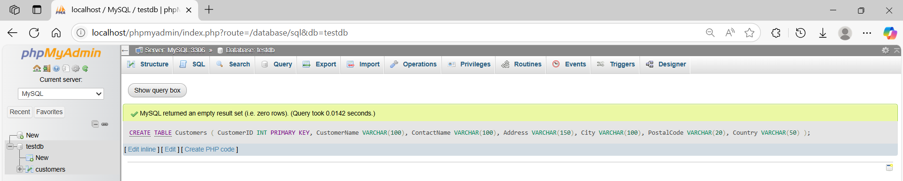
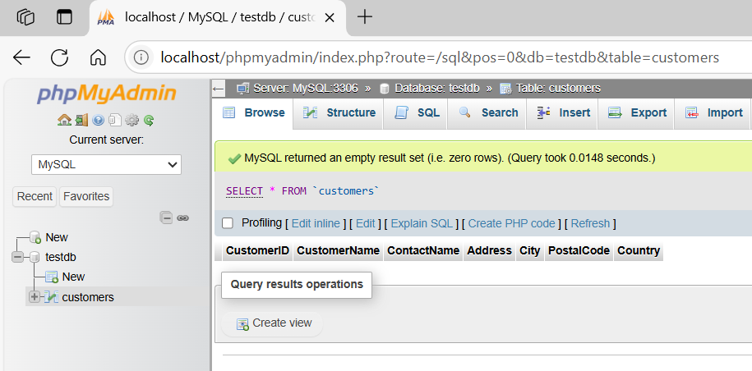
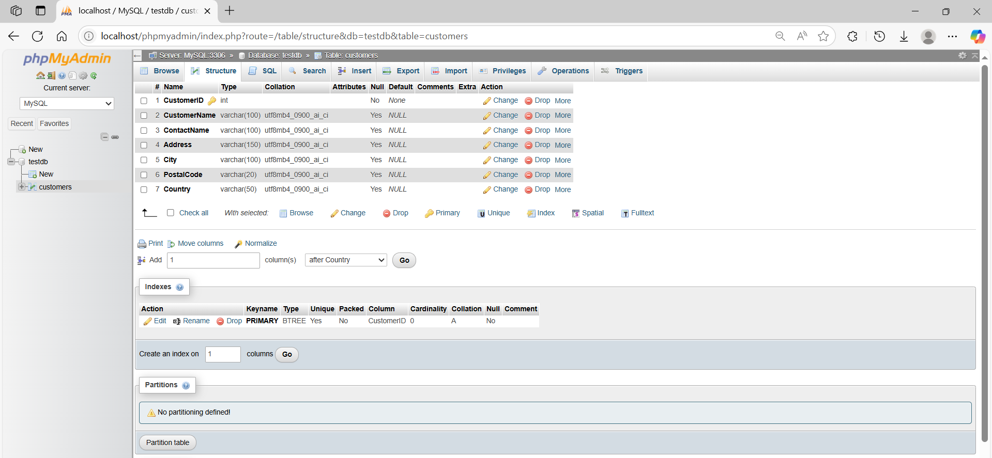

basic command
# Source: ScreenShot Source: Provided by: [Persons Table -> ID Column: 1, Name_En Column: Motasem Essam] -> Tool: [Automation Table -> ID Column: 16, Name_En Column: Screen Capture] -> From [Operating System: Wampserver64 -> phpmyadmin] on [6/11/2026]
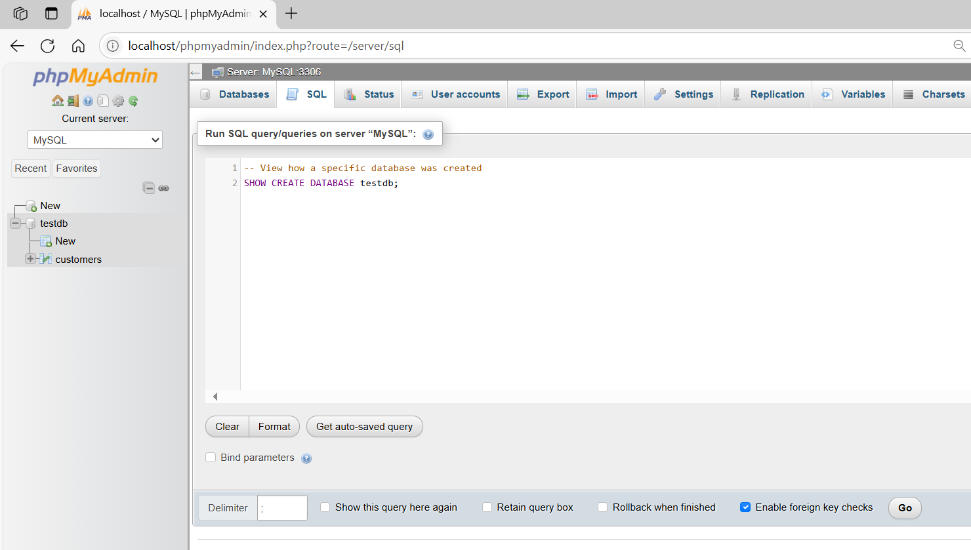
-- View how a specific database was created
SHOW CREATE DATABASE testdb;
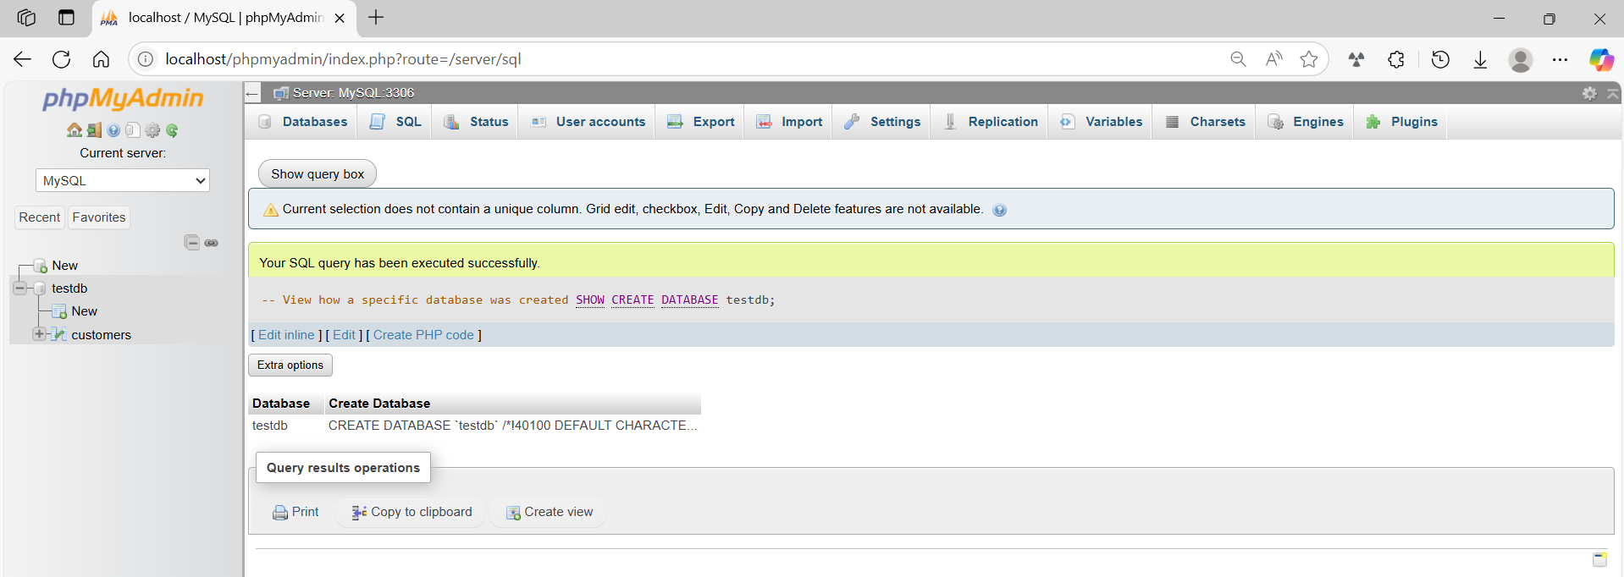

basic command
# Source: ScreenShot Source: Provided by: [Persons Table -> ID Column: 1, Name_En Column: Motasem Essam] -> Tool: [Automation Table -> ID Column: 16, Name_En Column: Screen Capture] -> From [Operating System: Wampserver64 -> phpmyadmin] on [6/11/2026]
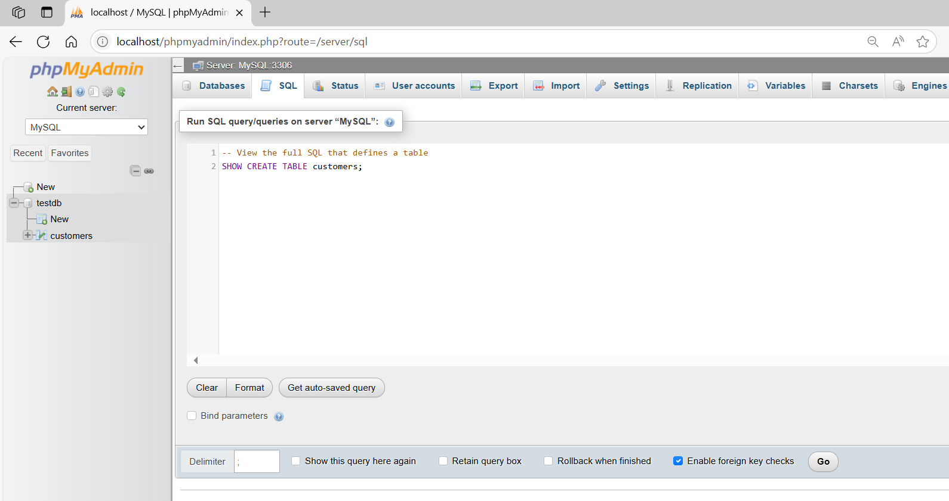
-- View the full SQL that defines a table
SHOW CREATE TABLE customers;
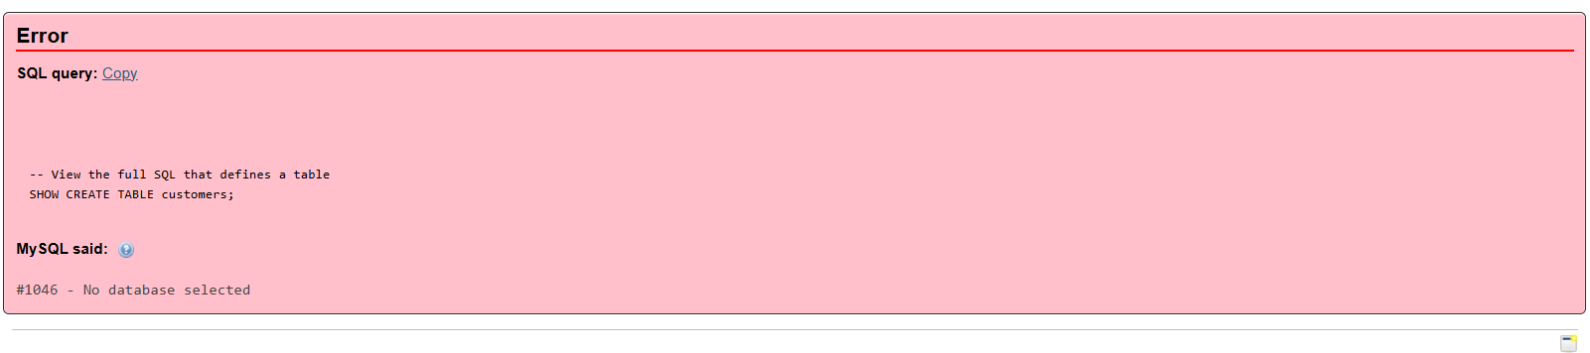
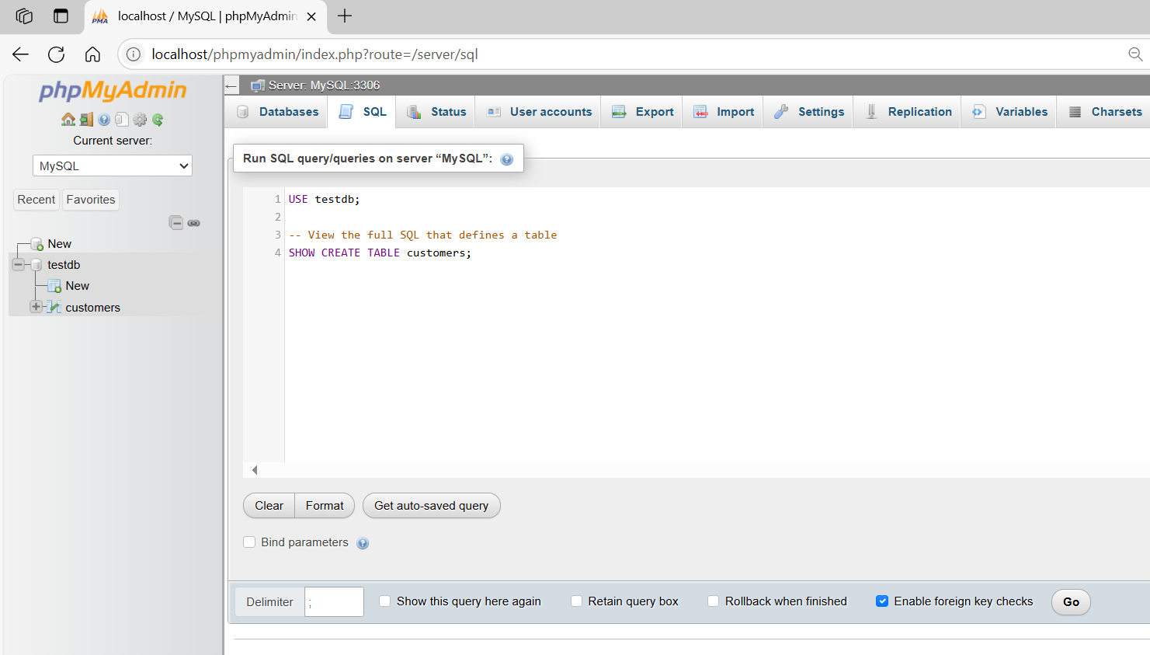
USE testdb;

-- View the full SQL that defines a table
SHOW CREATE TABLE customers;
